The GPhC register as of 31 January 2025 - Trend data

Contents
Our register 1
How to interpret our data 1
Overall register headlines 1
Register trends for pharmacists 2
Annotations to the pharmacist register 3
Register trends for pharmacy technicians 4
Register trends for pharmacies 6

Our register
We maintain a comprehensive, fully up-to-date pharmacy register of all pharmacists, pharmacy technicians and pharmacy premises. We will make sure that no-one can be identified from any data that we publish or share with others.

How to interpret our data
Our permanent register can change daily and at different times of the day. The data presented here is a snapshot of our register at 23:59:59 on the dates specified.
Please note that numbers by country are according to their registered home address. This does not necessarily mean that registrants are working in those countries or that they are in employment. This only shows that they are on the register. Where tables or figures refer to ‘All’ countries, this includes registrants with a registered address in England, Scotland, Wales, Northern Ireland, Channel Islands, Isle of Man and Overseas. Where tables refer to ‘Other’ countries, these are all countries outside of Great Britain.
The numbers of pharmacists with a prescribing annotation does not reflect how many are currently employed or working with their prescribing annotation. The data does not reflect how many pharmacy professionals are currently working but how many are on the GPhC register.
We continually review our data quality and content of our information to include the most accurate calculations. For improved data, we retrospectively update figures. This means when comparing this data with previously published data, you may see small changes. The end of financial year figures for previous years has small differences from published figures reported before.

Overall register headlines
- On 31 January 2025, the total number of pharmacy professionals on the register increased by 426 to 92,254 from 91,828 at the end of December 2024. The split by profession type remains steady with 71% pharmacists (65,586) and 29% pharmacy technicians (26,668). At the end of January 2025 there was a net increase of 394 pharmacists and 32 pharmacy technicians from December 2024.
- The number of pharmacists with a prescribing annotation has increased by 111 from 21,512 on 31 December 2024 to 21,623 on 31 January 2025. This represents 33% of registered pharmacists.
- There are 13,216 registered pharmacies on 31 January 2025, with a decrease of 31 in England, four in Scotland and two in Wales since last month. The overall numbers of pharmacies on the register and in England in particular have been falling in the last eight years. Numbers tend to fluctuate in Scotland and Wales.

Register trends for pharmacists
On 31 January 2025 the number of pharmacists on the register was 65,586. This is a net increase of 394 from 65,192 at the end of December 2024. Table 1 shows the trend in the snapshot of pharmacist numbers on our register over time by location of registered address up to the end of January each year for a direct comparison due to monthly variations.
Table 1: Snapshot of pharmacists on the register by location of registered address at the end of January for the last eight years
Snapshot date | All | England | Scotland | Wales
31 January 2025 | 65,586 | 55,481 | 5,628 | 2,791
31 January 2024 | 64,271 | 54,281 | 5,532 | 2,760
31 January 2023 | 62,527 | 52,672 | 5,400 | 2,707
31 January 2022 | 60,926 | 51,265 | 5,281 | 2,668
31 January 2021 | 56,817 | 47,676 | 4,948 | 2,542
31 January 2020 | 57,627 | 48,301 | 4,976 | 2,581
31 January 2019 | 56,325 | 46,975 | 4,900 | 2,530
31 January 2018 | 55,361 | 45,882 | 4,835 | 2,520
Compared to the same time last year, there is a 2.1% increase of pharmacists by 1,315 from 64,271 on 31 January 2024 to 65,586 on 31 January 2025.
Of the 65,586 pharmacists, 1,686 (2.6%) have a registered address outside of Great Britain. These include recent joiners who have yet to register an address in Great Britain. Others have left Great Britain and are overseas but would like to retain their GPhC registration or have yet to leave the register.
In Figure 1, the top teal blue line represents the total number of all pharmacists on the register at the end of January each year (including those with a registered address in England, Scotland, Wales, Northern Ireland, Channel Islands, Isle of Man and overseas). The dark purple line are the figures for England, the green line is for Scotland and the pink line is for Wales.

Figure 1: Snapshot of pharmacists on the register at the end of January each year by registered address location
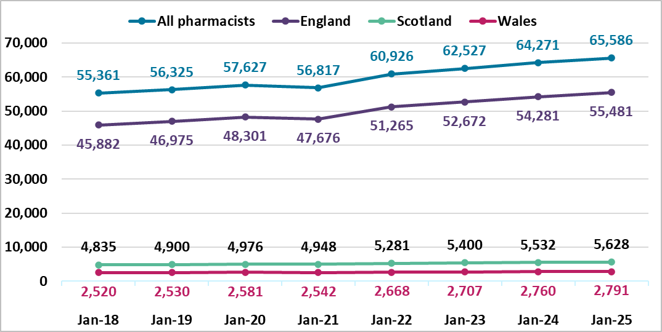

Annotations to the pharmacist register
On 31 January 2025, the number of registered pharmacists having a prescriber annotation has increased by 111 since the last month from 21,512 to 21,623 out of 65,586; this is 33% of the register. These include 21,418 independent prescribers and 205 supplementary prescribers only.
The breakdown of prescriber annotation by country of registered address is summarised in Table 2 below for pharmacists on 31 January 2025. The category of ‘Other’ includes countries that are overseas, Isle of Man, Northern Ireland and the Channel Islands. We do not know how many pharmacists are currently employed or are practising with their prescribing annotation.
Table 2: Number of pharmacists with prescribing annotation type by country of registered address on 31 January 2025
Prescriber annotation type | England | Scotland | Wales | Other | All
Independent prescriber | 17,454 | 2,630 | 1,220 | 114 | 21,418
Supplementary only prescriber | 141 | 52 | 8 | 4 | 205
Total | 17,595 | 2,682 | 1,228 | 118 | 21,623

Trend data on the total number of independent prescribers for the last eight years by country of registered address is summarised in Table 3 and Figure 2 below.
Table 3: Snapshot of pharmacists with an independent prescribing annotation at the end of January each year by country of registered address *supplementary prescribers only not included.
Snapshot date | All | England | Scotland | Wales
31 January 2025 | 21,418 | 17,454 | 2,630 | 1,220
31 January 2024 | 17,906 | 14,623 | 2,194 | 996
31 January 2023 | 15,075 | 12,297 | 1,867 | 838
31 January 2022 | 12,737 | 10,342 | 1,623 | 709
31 January 2021 | 10,779 | 8,773 | 1,368 | 587
31 January 2020 | 9,450 | 7,664 | 1,207 | 529
31 January 2019 | 7,727 | 6,192 | 1,084 | 409
31 January 2018 | 6,150 | 4,839 | 931 | 336

Figure 2: Snapshot of pharmacist independent prescribers on the register at the end of January each year by registered address location *supplementary prescribers only not included
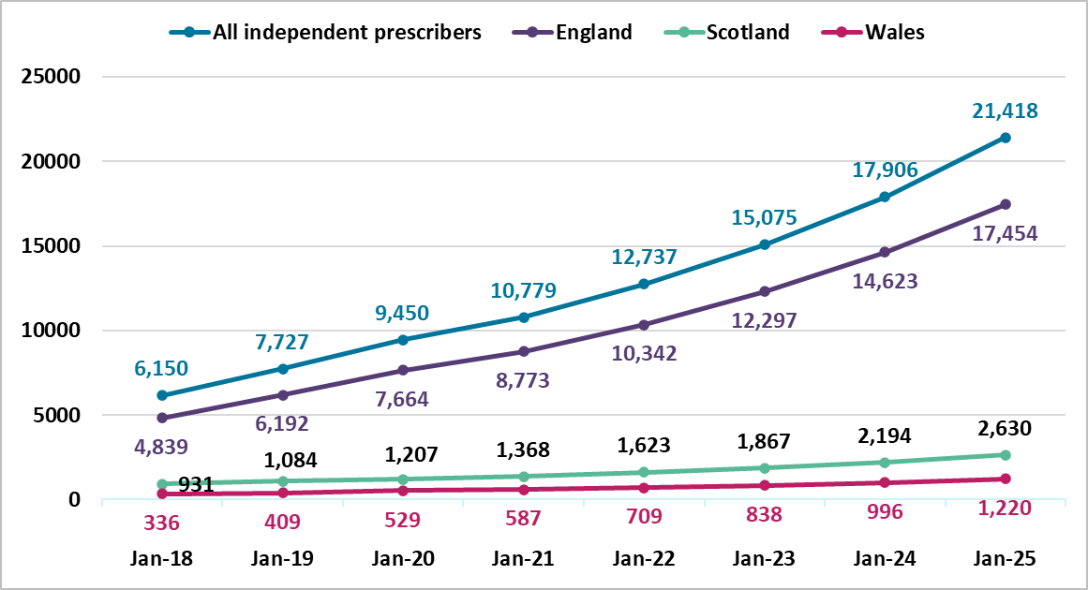

Register trends for pharmacy technicians
Table 4 and Figure 3 below shows the trend in pharmacy technician numbers on our register at the end of January from 2018 to 2025. This shows the register has been increasing year on year. There is a 3.6% increase by 923 from 25,745 in January 2024 to 26,668 in January 2025. The number of pharmacy technicians has increased by 32 (0.1%) since last month from 26,636 in December 2024.

Table 4: Snapshot of pharmacy technicians on the register by country of registered address at the end of January for the last eight years
Snapshot date | All | England | Scotland | Wales
31 January 2025 | 26,668 | 22,174 | 2,583 | 1,730
31 January 2024 | 25,745 | 21,437 | 2,462 | 1,672
31 January 2023 | 25,110 | 20,892 | 2,361 | 1,697
31 January 2022 | 24,810 | 20,665 | 2,298 | 1,684
31 January 2021 | 24,240 | 20,209 | 2,223 | 1,647
31 January 2020 | 23,612 | 19,666 | 2,177 | 1,613
31 January 2019 | 23,341 | 19,423 | 2,124 | 1,630
31 January 2018 | 23,378 | 19,495 | 2,091 | 1,635

For Figure 3 below, the top teal blue line represents the total number of pharmacy technicians on the register. The dark purple line is England, the green line is Scotland, and the pink line is Wales. The overall proportion of pharmacy technicians in each country has remained steady as the numbers increased over the last eight years.
Figure 3. Snapshot of pharmacy technicians on the register at the end of January each year by registered address location
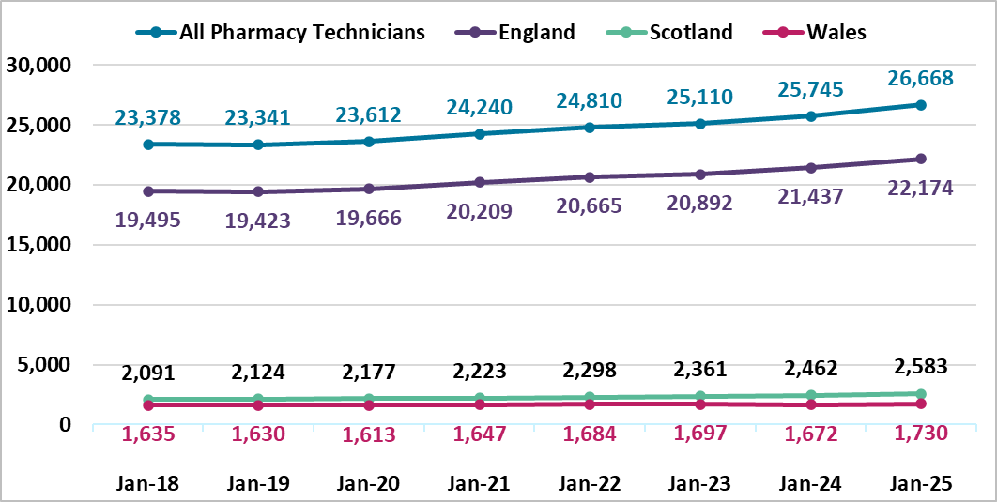

Register trends for pharmacies
On 31 January 2025 there were 13,216 registered pharmacies. 11,223 are in England, 1,288 in Scotland and 705 in Wales. This was a decrease of thirty-seven in the overall total from the last month, from 13,253 at the end of December 2024. There was a decrease in England of thirty-one, four in Scotland, and two in Wales. There is an overall decrease of 172 from the same time last year, a fall of 1.3%. Table 5 shows a decrease each year for all pharmacies and in England, with variations in Scotland and Wales by year.
Table 5: Snapshot of all pharmacies on the register by country of registered address at the end of January for the last eight years
Snapshot date | All | England | Scotland | Wales
31 January 2025 | 13,216 | 11,223 | 1,288 | 705
31 January 2024 | 13,388 | 11,379 | 1,295 | 714
31 January 2023 | 13,804 | 11,779 | 1,300 | 725
31 January 2022 | 13,855 | 11,828 | 1,297 | 730
31 January 2021 | 13,967 | 11,934 | 1,299 | 734
31 January 2020 | 14,176 | 12,140 | 1,300 | 736
31 January 2019 | 14,299 | 12,267 | 1,292 | 740
31 January 2018 | 14,400 | 12,361 | 1,293 | 746
For Figure 4 below, the top teal blue line represents the total number of pharmacies on the register. The dark purple line is England, the green line is Scotland, and the pink line is Wales. The overall proportion of pharmacies in each country has remained steady.

Figure 4. Snapshot of pharmacies on the register at the end of January each year by registered address location
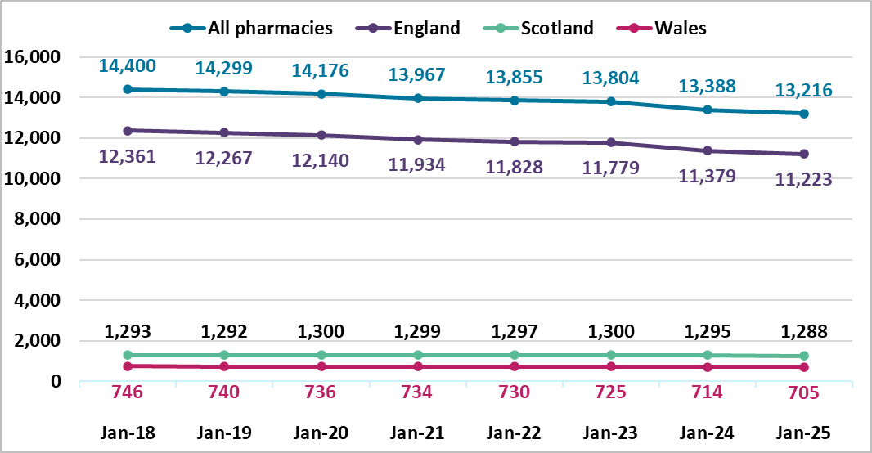

Annotations are additional qualifications or responsibilities held by a registrant. An independent prescriber can prescribe any medicine for any condition (excluding 3 Controlled Drugs for the treatment of addiction). A supplementary prescriber can prescribe any medicine for any condition within an agreed clinical management plan.

