The GPhC register as of 28 February 2025 - Trend data

Contents
Our register 1
How to interpret our data 1
Overall register headlines 1
Register trends for pharmacists 2
Annotations to the pharmacist register 3
Register trends for pharmacy technicians 4
Register trends for pharmacies 6

Our register
We maintain a comprehensive, fully up-to-date pharmacy register of all pharmacists, pharmacy technicians and pharmacy premises. We will make sure that no-one can be identified from any data that we publish or share with others.

How to interpret our data
Our permanent register can change daily and at different times of the day. The data presented here is a snapshot of our register at 23:59:59 on the dates specified.
Please note that numbers by country are according to their registered home address. This does not necessarily mean that registrants are working in those countries or that they are in employment. This only shows that they are on the register. Where tables or figures refer to ‘All’ countries, this includes registrants with a registered address in England, Scotland, Wales, Northern Ireland, Channel Islands, Isle of Man and Overseas. Where tables refer to ‘Other’ countries, these are all countries outside of Great Britain.
The numbers of pharmacists with a prescribing annotation does not reflect how many are currently employed or working with their prescribing annotation. The data does not reflect how many pharmacy professionals are currently working but how many are on the GPhC register.
We continually review our data quality and content of our information to include the most accurate calculations. For improved data, we retrospectively update figures. This means when comparing this data with previously published data, you may see small changes. The end of financial year figures for previous years has small differences from published figures reported before.

Overall register headlines
- On 28 February 2025, the total number of pharmacy professionals on the register increased by 258 to 92,512 from 92,254 at the end of January 2025. The split by profession type remains steady with 71% pharmacists (65,744) and 29% pharmacy technicians (26,768). At the end of February 2025 there was a net increase of 158 pharmacists and 100 pharmacy technicians from January 2025.
- The number of pharmacists with a prescribing annotation has increased by 180 from 21,623 on 31 January 2025 to 21,803 on 28 February 2025. This represents 33% of registered pharmacists.
- There are 13,206 registered pharmacies on 28 February 2025, with a decrease of eleven in England, an increase of one in Scotland with the number of registered pharmacies in Wales remaining constant since last month. The overall numbers of pharmacies on the register and in England in particular have been falling in the last eight years. Numbers tend to fluctuate in Scotland and Wales.

Register trends for pharmacists
On 28 February 2025 the number of pharmacists on the register was 65,744. This is a net increase of 158 from 65,586 at the end of January 2025. Table 1 shows the trend in the snapshot of pharmacist numbers on our register over time by location of registered address up to the end of February each year for a direct comparison due to monthly variations.
Table 1: Snapshot of pharmacists on the register by location of registered address at the end of February for the last eight years
Snapshot date | All | England | Scotland | Wales
28 February 2025 | 65,744 | 55,619 | 5,637 | 2,796
29 February 2024 | 64,380 | 54,375 | 5,538 | 2,759
28 February 2023 | 62,615 | 52,750 | 5,403 | 2,713
28 February 2022 | 61,100 | 51,417 | 5,288 | 2,673
28 February 2021 | 56,829 | 47,675 | 4,955 | 2,541
29 February 2020 | 57,627 | 48,301 | 4,975 | 2,580
28 February 2019 | 56,291 | 46,963 | 4,898 | 2,530
28 February 2018 | 55,344 | 45,870 | 4,832 | 2,521
Compared to the same time last year, there is a 2.1% increase of pharmacists by 1,364 from 64,380 on 29 February 2024 to 65,744 on 28 February 2025.
Of the 65,744 pharmacists, 1,692 (2.6%) have a registered address outside of Great Britain. These include recent joiners who have yet to register an address in Great Britain. Others have left Great Britain and are overseas but would like to retain their GPhC registration or have yet to leave the register.
In Figure 1, the top teal blue line represents the total number of all pharmacists on the register at the end of February each year (including those with a registered address in England, Scotland, Wales, Northern Ireland, Channel Islands, Isle of Man and overseas). The dark purple line are the figures for England, the green line is for Scotland and the pink line is for Wales.

Figure 1: Snapshot of pharmacists on the register at the end of February each year by registered address location
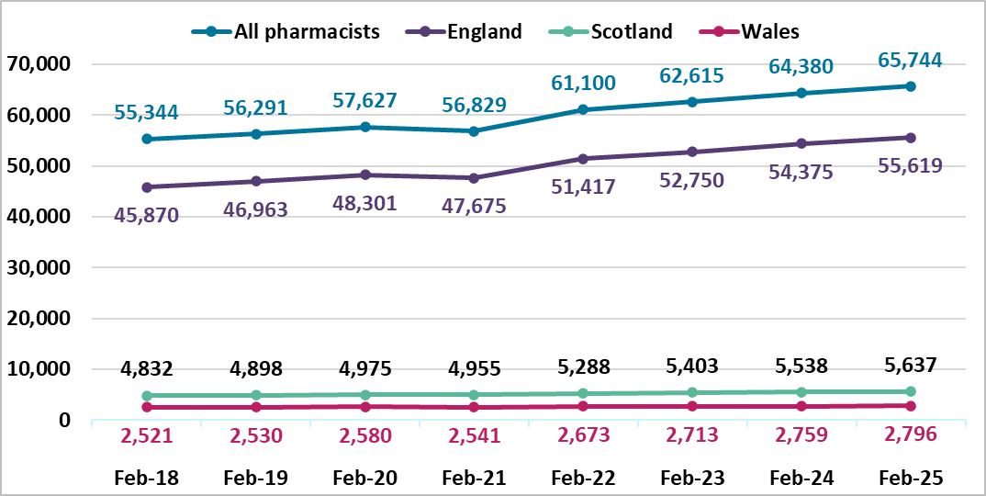

Annotations to the pharmacist register
On 28 February 2025, the number of registered pharmacists having a prescriber annotation has increased by 180 since the last month from 21,623 to 21,803 out of 65,744; this is 33% of the register. These include 21,599 independent prescribers and 204 supplementary prescribers only.
The breakdown of prescriber annotation by country of registered address is summarised in Table 2 below for pharmacists on 28 February 2025. The category of ‘Other’ includes countries that are overseas, Isle of Man, Northern Ireland and the Channel Islands. We do not know how many pharmacists are currently employed or are practising with their prescribing annotation.
Table 2: Number of pharmacists with prescribing annotation type by country of registered address on 28 February 2025
Prescriber annotation type | England | Scotland | Wales | Other | All
Independent prescriber | 17,588 | 2,674 | 1,225 | 112 | 21,599
Supplementary only prescriber | 141 | 51 | 8 | 4 | 204
Total | 17,729 | 2,725 | 1,233 | 116 | 21,803

Trend data on the total number of independent prescribers for the last eight years by country of registered address is summarised in Table 3 and Figure 2 below.
Table 3: Snapshot of pharmacists with an independent prescribing annotation at the end of February each year by country of registered address *supplementary prescribers only not included.
Snapshot date | All | England | Scotland | Wales
28 February 2025 | 21,599 | 17,588 | 2,674 | 1,225
29 February 2024 | 18,119 | 14,781 | 2,245 | 998
28 February 2023 | 15,175 | 12,379 | 1,879 | 844
28 February 2022 | 12,821 | 10,403 | 1,643 | 712
28 February 2021 | 10,829 | 8,811 | 1,373 | 594
29 February 2020 | 9,523 | 7,726 | 1,212 | 536
28 February 2019 | 7,837 | 6,288 | 1,091 | 416
28 February 2018 | 6,201 | 4,885 | 936 | 336

Figure 2: Snapshot of pharmacist independent prescribers on the register at the end of February each year by registered address location *supplementary prescribers only not included
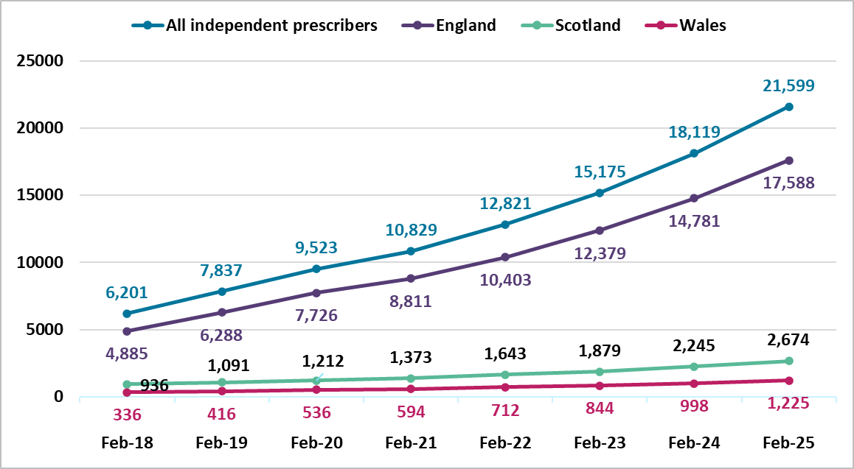

Register trends for pharmacy technicians
Table 4 and Figure 3 below shows the trend in pharmacy technician numbers on our register at the end of February from 2018 to 2025. This shows the register has been increasing year on year. There is a 3.4% increase by 885 from 25,883 in February 2024 to 26,768 in February 2025. The number of pharmacy technicians has increased by 100 (0.4%) since last month from 26,668 in January 2025.

Table 4: Snapshot of pharmacy technicians on the register by country of registered address at the end of February for the last eight years
Snapshot date | All | England | Scotland | Wales
28 February 2025 | 26,768 | 22,257 | 2,591 | 1,739
29 February 2024 | 25,883 | 21,531 | 2,476 | 1,700
28 February 2023 | 25,192 | 20,960 | 2,369 | 1,699
28 February 2022 | 24,855 | 20,706 | 2,299 | 1,684
28 February 2021 | 24,319 | 20,270 | 2,234 | 1,651
29 February 2020 | 23,645 | 19,700 | 2,181 | 1,608
28 February 2019 | 23,333 | 19,414 | 2,124 | 1,628
28 February 2018 | 23,386 | 19,506 | 2,088 | 1,636
For Figure 3 below, the top teal blue line represents the total number of pharmacy technicians on the register. The dark purple line is England, the green line is Scotland, and the pink line is Wales. The overall proportion of pharmacy technicians in each country has remained steady as the numbers increased over the last eight years.
Figure 3. Snapshot of pharmacy technicians on the register at the end of February each year by registered address location
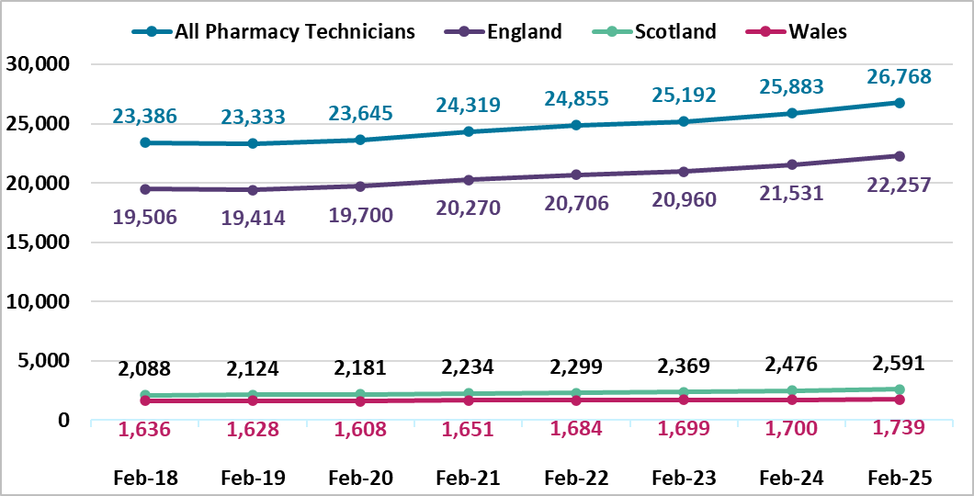

Register trends for pharmacies
On 28 February 2025 there were 13,206 registered pharmacies. 11,212 are in England, 1,289 in Scotland and 705 in Wales. This was a decrease of ten in the overall total from the last month, from 13,216 at the end of January 2025. There was a decrease in England of eleven, an increase of one in Scotland with the number of registered pharmacies in Wales remaining constant. There is an overall decrease of 148 from the same time last year, a fall of 1.1%. Table 5 shows a decrease each year for all pharmacies and in England, with variations in Scotland and Wales by year.
Table 5: Snapshot of all pharmacies on the register by country of registered address at the end of February for the last eight years
Snapshot date | All | England | Scotland | Wales
28 February 2025 | 13,206 | 11,212 | 1,289 | 705
29 February 2024 | 13,354 | 11,353 | 1,290 | 711
28 February 2023 | 13,812 | 11,787 | 1,300 | 725
28 February 2022 | 13,852 | 11,823 | 1,300 | 729
28 February 2021 | 13,973 | 11,940 | 1,299 | 734
29 February 2020 | 14,177 | 12,142 | 1,299 | 736
28 February 2019 | 14,298 | 12,266 | 1,291 | 741
28 February 2018 | 14,345 | 12,307 | 1,292 | 746
For Figure 4 below, the top teal blue line represents the total number of pharmacies on the register. The dark purple line is England, the green line is Scotland, and the pink line is Wales. The overall proportion of pharmacies in each country has remained steady.

Figure 4. Snapshot of pharmacies on the register at the end of February each year by registered address location
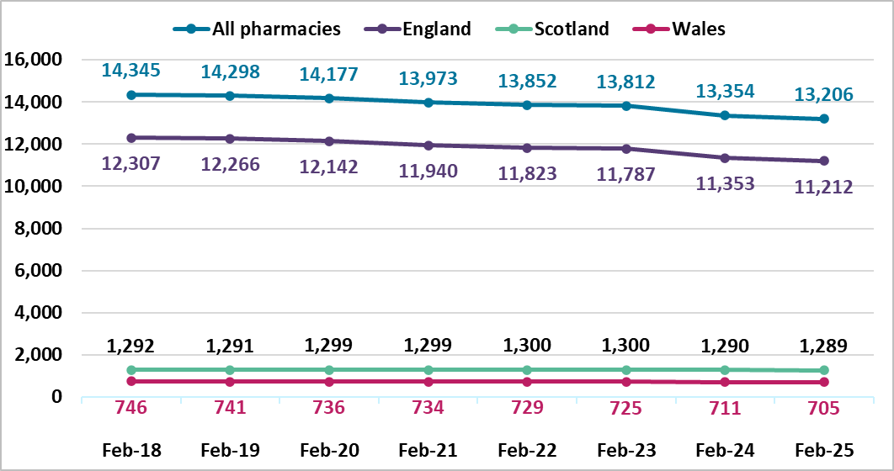

Annotations are additional qualifications or responsibilities held by a registrant. An independent prescriber can prescribe any medicine for any condition (excluding 3 Controlled Drugs for the treatment of addiction). A supplementary prescriber can prescribe any medicine for any condition within an agreed clinical management plan.

